Name:……………………..………………………………………….Signature:..………… School:…………………………………………………………Reference No:…………….
P530/1
Biology
Paper 1
April 2024
2 ½ hours

MEHAN ASPIRE SECONDARY SCHOOL
Uganda Advanced Certificate of Education
END OF TERM I EXAMINATION, 2024

BIOLOGY (THEORY) Paper 1
2 hours 30 minutes

Instructions to Candidates:

Answer all questions in both sections A and B.

Answers to Section A should be written in the boxes provided

Answers to Section B should be written in spaces provided.

No additional answer sheets should be attached to this booklet.

For Examiner’s use only
Section | Mark | Examiner’s No.
A: 1-40
B: 41
42
43
44
45
46
Total

SECTION A: 40 marks

1. What are the products of the light dependent reactions of photosynthesis?

A. ATP, RuBP and reduced NAD

B. ATP, oxygen and reduced NADP C. PGA, oxygen and reduced NAD D. PGA, reduced NADP and RuBP

2. A man has haemophilia. Which statement correctly describes the inheritance of the gene causing his condition?

A. He inherited the recessive allele from his mother. B. He inherited the dominant allele from his father. C. He can pass the recessive allele to a son.
D. He can pass the dominant allele to a daughter.

3. Which type of immunity is provided by vaccination?

A. artificial active B. artificial passive C. natural active
D. natural passive

4. In which structure is cartilage found?

A. alveolus

B. bronchiole

C. capillary

D. trachea

5. In a reaction controlled by an enzyme, which of the following graphs shows the effect of enzyme concentration on the rate of the reaction?

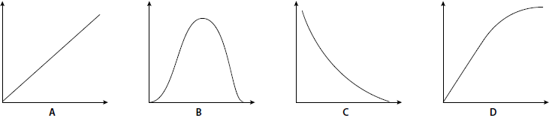

6. Which term describes both collagen and haemoglobin?

A. enzymes

B. fibrous proteins C. globular proteins D. macromolecules

7. If sucrose is actively loaded into a sieve tube, which combination of changes takes place in the sieve tube?

 | Solute potential | Hydrogen ion concentration
A | Becomes more negative | Decreases
B | Becomes more negative | Increases
C | Becomes less negative | Decreases
D | Becomes less negative | Increases

8. What does not occur in the conversion of glucose to two molecules of pyruvate in the cytoplasm of eukaryotic cell ?

A. hydrolysis of ATP

B. phosphorylation of ATP

C. phosphorylation of triose sugar

D. reduction of NAD

9. The diagram shows the changes in blood pressure as blood flows through the blood vessels in the human systemic circulatory system.

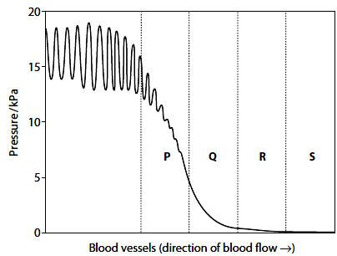

Which one correctly identifies the vessels labelled P to S?

 | P | Q | R | S
A | Artery | Capillary | Arteriole | Venule
B | Arteriole | Artery | Venule | Capillary
C | Artery | Arteriole | Capillary | Venule
D | Venule | Capillary | Arteriole | Artery

10. Which statements about the concentrations of hormones in the human menstrual cycle are correct?

1. Shortly before ovulation, the concentration of oestrogen is high and concentration of progesterone low.

2. During the last quarter of the cycle, the concentrations of oestrogen and progesterone fall.

3. At the end of menstruation, the concentration of oestrogen is low but rising, and the concentration of progesterone is low.

4. Just before ovulation, the concentrations of LH and FSH suddenly rise.

A. 1, 2, 3 and 4

B. 1, 2 and 4 only

C. 2 and 3 only

D. 3 and 4 only

11. Which one of the following associations is parasitic?

A. Phytophthora infestans fungus on potato leaves

B. Colonial hydroid Hydractinia on the shells of the hermit crab

C. Lichens

D. Bacteria in rumen of ruminant

12. A single base substitution in the genetic code is less harmful than a single base deletion since the substituted base usually results into new codon specifying the same amino acid as the original codon. The property of the genetic code attributed to this is…….

A. degeneracy

B. Non-overlapping

C. Punctuated

D. Triplet code

13. Infants have a lot of brown adipose tissue since they face a problem of
A. hypoglycaemia B. hypothyroidism C. Hyperthermia D. Hypothermia
14. The tendency of one spece to limit others access to resources regardless of abundance is commonly known as?

A. Exploitation competition

B. Competitive exclusion principle

C. Interference competition

D. Resource partitioning

15. Which of the following taxonomic levels contains organisms that share the most recent common ancestor?

A. Class B. Order C. Family
D. Kingdom

16. A plant becomes etiolated when

A. grown in the dark

B. grown in soils deficient of nitrogen

C. treated with gibberellic acid

D. its apical bud is removed

17. Which one of the following processes is passive?

A. Gradual filling of contractile vacuole in amoeba with water

B. Secretion of salts in halophytes across hydathodes

C. Generation of root pressure by endodermal cells in plant roots

D. Evaporation of water across the leaf surface on a hot day

18. Induction of development of a giant larval instar in an insect is done through

A. surgical removal of corpus allatum gland

B. decapitating the insect

C. injecting it with large doses of ecdysone

D. injecting it with large doses of juvenile hormone

19. Which one of the following hormones would not result into a cascade effect on the target organ?
A. Adrenaline

B. Testosterone

C. Antidiuretic hormone

D. Insulin

20. The life cycle of Pteridophytes involves a dominant sporophyte stage that produces spores. Which one of the following statements is true?

A. Haploid spores are produced through meiosis B. Haploid spores are produced through mitosis C. Diploid spores are produced through meiosis D. Diploid spores are produced through mitosis

21. Marine water Elasmobranchii create water balance through

A. Eating salty food

B. Retaining urea in their tissues

C. Excreting hypotonic urine

D. Secreting salts across their gills

22. Which of the following best describes bioaccumulation?

A. Rise in the concentration of organochemicals within the tissues of an organism

B. Conversion of solar energy to chemical energy in form of sugars by primary producers. C. Accumulation of certain molecules at high concentration at upper trophic levels.
D. Increase in nutrients that lead to pollution.

23. Which one of the following is not a characteristic of senescence in living organisms?

A. Mistakes in protein synthesis

B. Auto-immunity

C. Inefficient homeostasis

D. Regeneration of tissues

24. Some columnar epithelium of the body possess brush borders on their surface in order to
A. increase the surface area over which absorption occurs

B. Shorten diffusion distance for selective reabsorption

C. cleanse the surface off foreign bodies

D. secrete mucus layer to effect fast dissolution of gases

25. In a typical large human population, only one person in 10 000 is albino. Given that albinism is a recessive character, what is the frequency of heterozygotes as estimated from Hardy- Weinberg formula?

A. 0.01

B. 0.99

C. 0.02

D. 0.0002

26. Which one of the following vitamins is required in the formation of red blood corpuscles?

A. vitamin A B. vitamin B12
C. vitamin K

D. Vitamin D

27. If a steady stimulus is maintained; the receptor cell gradually ceases to discharge action potentials. In this state, the cell is said to undergo

A. summation

B. adaptation

C. mutual inhibition

D. depolarization

28. Which one of the following conditions is not associated with a raised cholesterol level with blood?

A. Arteriosclerosis B. Atherosclerosis C. Hypotension

D. Thrombosis

29. The term physiological drought in plants refers to

A. Plant losing more water through transpiration than what they absorb through the roots

B. Plants growing in water-deficient soils

C. Presence of water in a form that plants can not readily access

D. Drooping of plant due plants loosing excess water by transpiration

30. Which one of the following is responsible for saltatory conduction in myelinated neurones?

A. axon membranes B. nodes of Ranvier C. Schwann cells
D. voltage-gated channel proteins

31. Which one of the following extra-embryonic membranes form the fetal portion of the placenta in man?

A. Allantois and Yolk sac B. Chorion and allantois C. Chorion and amnion
D. Allantois and amnion

32. The behavioral response in adult animals that enables them to recognize their own offspring shortly after giving birth is known as

A. Insight

B. Latent learning

C. Instinct

D. Imprinting

33. In dim light; rod cells in the human eye are
A. hyperpolarised
B. depolarised

C. polarised

D. repolarised

34. Which one of the following pairs of hormones demonstrate synergism in plants?

A. auxins and cytokinins

B. Abscisic acid and Gibberellins

C. Indoleacetic acid and Gibberellins

D. Cytokinins and Gibberellins

35. Which one of the following is not consistent with both facilitated diffusion and active transport?

A. Both move molecules down the concentration gradient

B. Both are affected by drugs

C. Both employ transmembrane proteins

D. A particular molecule may move across cell membrane by both processes

36. Which one of the following trophic levels possess organisms which have the greatest effect on changes in predator populations?

A. Producers

B. Decomposers

C. Primary consumers

D. Secondary consumers

37. An amino acid can be referred to as a Zwitterion because; A. In acidic solutions, it reacts with hydroxyl ions
B. In a neutral solution, it has both negative and positive charges.

C. In alkaline solutions, it can release hydroxyl ions. D. In a neutral solution, it has a stable structure.
38. The Mendelian F2 9:3:3:1 ratio is a ratio of

A. genotypes in a cross of two parents that differ in one trait

B. genotypes in a cross of two parents that differ in two traits C. phenotypes in a cross of two parents that differ in one trait D. phenotypes in a cross of two parents that differ in two traits

39. Starlings produce an average of five eggs in each clutch. If there are more than five, the parents cannot adequately feed the young. If there are fewer than five, predators may destroy the entire clutch, this is an example of

A. Disruptive selection B. Directional selection C. Sexual selection
D. Stabilizing selection

40. Which of the following is true about non-competitive inhibition in enzyme catalysed reactions?
A. the degree of inhibition is independent of the substrate concentration

B. the inhibitor has a similar structural and chemical composition with the substrate

C. the degree of inhibition decreases with increase in substrate concentration

D. the shape of the enzyme is not affected by the inhibitor.

SECTION B: 60 marks

41. (a) Give three differences between the structure of glycogen and collagen. (03 marks)

…………………………………………………………………………………………………………

…………………………………………………………………………………………………………

…………………………………………………………………………………………………………

…………………………………………………………………………………………………………

…………………………………………………………………………………………………………

…………………………………………………………………………………………………………

…………………………………………………………………………………………………………

…………………………………………………………………………………………………………

…………………………………………………………………………………………………………

…………………………………………………………………………………………………………

(b) Collagen is found in the ligaments which hold bones together at joints. State the properties of collagen that make it suitable for this purpose. (03 marks)

…………………………………………………………………………………………………………

…………………………………………………………………………………………………………

…………………………………………………………………………………………………………

…………………………………………………………………………………………………………

…………………………………………………………………………………………………………

………………………………………………………………………………………………………..

(c) Give four features of glycogen that enable it to act as an efficient storage substance in animal cells. (04 marks)

…………………………………………………………………………………………………………

…………………………………………………………………………………………………………

…………………………………………………………………………………………………………

…………………………………………………………………………………………………………

…………………………………………………………………………………………………………

…………………………………………………………………………………………………………

…………………………………………………………………………………………………………

…………………………………………………………………………………………………………

…………………………………………………………………………………………………………

…………………………………………………………………………………………………………

42. The graph shows the relationship between the biomass of primary consumers, secondary consumers and producers.

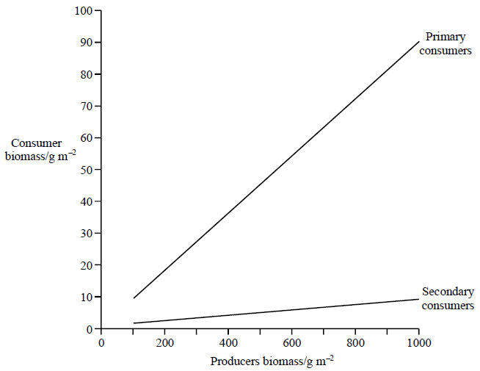

(a) Define the term biomass. (01 mark)

…………………………………………………………………………………………………………

……………………………………………………………………………………………………

(b) What conclusions can be drawn from the graph? (03 marks)

…………………………………………………………………………………………………………

…………………………………………………………………………………………………………

…………………………………………………………………………………………………………

…………………………………………………………………………………………………………

…………………………………………………………………………………………………………

…………………………………………………………………………………………

(c) Give three reasons why not all of the energy in producer biomass can be converted into energy in primary consumer biomass. (03 marks)

…………………………………………………………………………………………………………

…………………………………………………………………………………………………………

…………………………………………………………………………………………………………

…………………………………………………………………………………………………………

……………………………………………………………………………………………

(d) How does trophic efficiency vary across trophic levels from producers through a series of consumers? Give two reasons for your answer. (03 marks)

…………………………………………………………………………………………………………

…………………………………………………………………………………………………………

…………………………………………………………………………………………………………

…………………………………………………………………………………………………………

…………………………………………………………………………………………………………..

43. (a) What is meant by each of the following;

(i) sex-limited character. (02 Marks)

…………………………………………………………………………………………………………

…………………………………………………………………………………………………………

………………………………………………………………………………………………………….

(ii) sex-linked character. (02 marks)

…………………………………………………………………………………………………………

…………………………………………………………………………………………………………

………………………………………………………………………………………………………….. (b) In fruit fly Drosophila, body colour is either grey or black, and wing length is either normal or vestigial. The two characters are autosomal. A normal wing grey-bodied male fruit fly was mated with a vestigial wing black-bodied female fruit fly. All offspring were normal wing grey-bodied. On maturity, when these offspring were selfed, it resulted into F2 progeny of about 75% normal wing grey body and 25% vestigial wing black body. Using appropriate symbols, explain the results
obtained. (06 marks)

…………………………………………………………………………………………………………

…………………………………………………………………………………………………………

…………………………………………………………………………………………………………

…………………………………………………………………………………………………………

…………………………………………………………………………………………………………

…………………………………………………………………………………………………………

…………………………………………………………………………………………………………

…………………………………………………………………………………………………………

…………………………………………………………………………………………………………

…………………………………………………………………………………………………………

…………………………………………………………………………………………………………

…………………………………………………………………………………………………………

…………………………………………………………………………………………………………

…………………………………………………………………………………………………………

…………………………………………………………………………………………………………

…………………………………………………………………………………………………………

…………………………………………………………………………………………………………

…………………………………………………………………………………………………………

44. (a) State three physiological differences between xylem and phloem tissue. (03 marks)

…………………………………………………………………………………………………………

…………………………………………………………………………………………………………

…………………………………………………………………………………………………………

…………………………………………………………………………………………………………

…………………………………………………………………………………………………………

………………………………………………………………………………………………………..

(b) How are plant sugars loaded into the sieve tubes according to the pressure flow hypothesis? (04 marks)
…………………………………………………………………………………………………………

…………………………………………………………………………………………………………

…………………………………………………………………………………………………………
…………………………………………………………………………………………………………

…………………………………………………………………………………………………………

…………………………………………………………………………………………………………

…………………………………………………………………………………………………………

…………………………………………………………………………………………………………

…………………………………………………………………………………………………………

……………………………………………………………………………………………………….. (c) Suggest three evidences that translocation of sugars from source to sink in plants is an active process. (03 marks)
…………………………………………………………………………………………………………

…………………………………………………………………………………………………………

…………………………………………………………………………………………………………

…………………………………………………………………………………………………………

45. (a) How in the respiratory chain do electrons from FADH2 and NADH2 passing through cytochromes liberate energy for the ATP synthesis? (06 marks)
…………………………………………………………………………………………………………

…………………………………………………………………………………………………………

…………………………………………………………………………………………………………

…………………………………………………………………………………………………………

…………………………………………………………………………………………………………

…………………………………………………………………………………………………………

…………………………………………………………………………………………………………

…………………………………………………………………………………………………………

…………………………………………………………………………………………………………

…………………………………………………………………………………………………………

…………………………………………………………………………………………………………

…………………………………………………………………………………………………………

…………………………………………………………………………………………………………

…………………………………………………………………………………………………………

…………………………………………………………………………………………………………

…………………………………………………………………………………………………………

(b) How does the poison cyanide act upon the aerobic respiration? (04 marks)

…………………………………………………………………………………………………………

…………………………………………………………………………………………………………

…………………………………………………………………………………………………………

…………………………………………………………………………………………………………

…………………………………………………………………………………………………………

…………………………………………………………………………………………………………
46. (a) Saliva secretion is controlled by a reflex action. Complete the table below to show the components of this reflex. (03 marks)

Stimulus
Receptor
Effector
Response | Secretion of saliva

(b) The graph shows the volume of gastric juice produced in the 4 hours following a meal.

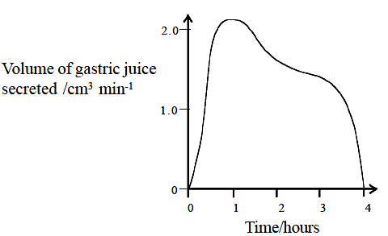

(b) Gastric juice secretion is controlled partly by reflex action and partly by a hormone, gastrin. Which of these two would you expect to be mainly responsible for controlling gastric secretion?

(i) Immediately after a meal has been eaten? (0½ marks)

……………………………………………………………………………………………………….

(ii) 1 hour after a meal? (0½ marks)

……………………………………………………………………………………………………….

(iii) Give reason for your answers. (02 marks)

…………………………………………………………………………………………………………

…………………………………………………………………………………………………………

…………………………………………………………………………………………………………

…………………………………………………………………………………………………………

…………………………………………………………………………………………………………

……………………………………………………………………………………………………..

(c) What are the advantages of having both the nervous and endocrine systems controlling gastric juice secretion? (04 marks)

…………………………………………………………………………………………………………

…………………………………………………………………………………………………………

…………………………………………………………………………………………………………

…………………………………………………………………………………………………………

…………………………………………………………………………………………………………

…………………………………………………………………………………………………………

…………………………………………………………………………………………………………

…………………………………………………………………………………………………………

…………………………………………………………………………………………………………

…………………………………………………………………………………………………………

END.

